To All Frenship ISD Parents:

The Frenship ISD Athletic Training staff would like to welcome you to another year of Frenship ISD athletics/band. To ensure your child’s health and eligibility, we have assembled a packet of all necessary paperwork required for participation in any and all sports and high school marching band.

Fill out required forms electronically through Rank One by going to frenshipisd.rankone.com (see reverse side for instructions). The medical history and physical examination forms attached must be completed and signed by a physician and turned in.

FAILURE TO PROPERLY AND COMPLETELY FILL-OUT AND SIGN ALL FORMS COULD RESULT IN YOUR CHILD BEING INELIGIBLE TO PARTICIPATE IN ATHLETICS/BAND!

Your child will need a new physical examination if he/she will be in 7th through the 12th grade for the upcoming school year. The medical history portion of the physical form must be completed and signed before your child will be seen by a physician. The schedule for the physicals is:

Middle School Dates: High School Dates:
Tuesday April 21st Tuesday April 7th
7:30 AM Heritage Middle School 1:00 PM @ MHS Panther Pit
1:00 PM Terra Vista Middle School

The cost of the physical exam is $20.00 (make checks payable to MHS Booster Club). This event is not mandatory and students may obtain their physicals from other healthcare providers. The medical professionals providing this service to Frenship ISD are the physicians and residents from Texas Tech Pediatrics. The physicals MUST be on the current physical exam form, updated and released by the UIL in 2026. You can also access the form online at http://www.uil.utexas.edu/athletics/forms.

If you have any questions or need to reach us for any reason, please do not hesitate to contact us at the Athletic Office at 866-4480. Thank you for your support and cooperation.

Sincerely,

Memorial High School Athletic Training Staff

- Go to frenshipisd.rankone.com
- Log in or select “Continue with One Time Login Code”
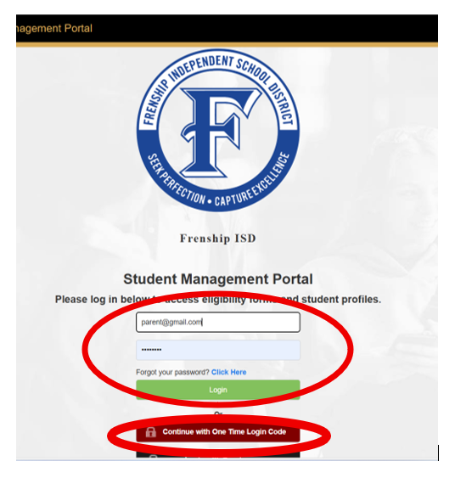
- Make sure your Student is listed under “Student Profiles.” If not, click “Add Student.”
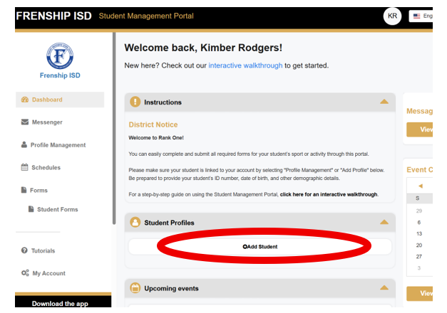
- Enter your student’s Last Name and Student ID Number.
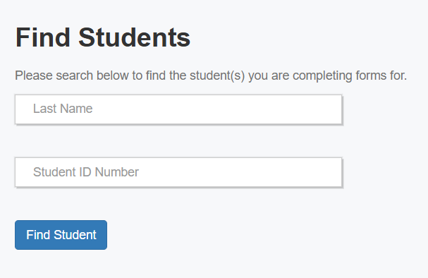
- Select the sport or activity your student will be participating in then click “Start Forms.”
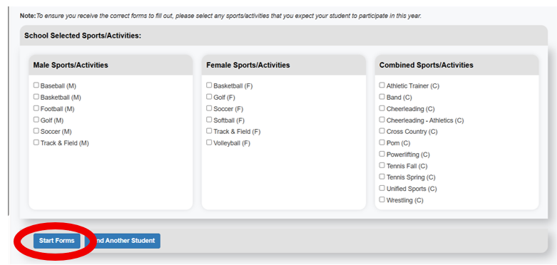
- Complete ALL forms!

